Lookup Transformation

-- LOOKUP TRANSFORMATIONS

M_STUDENT_SCORE_LKP

// Scores table is the lookup table

create table scores(

primary_sub_id number primary key,

primary_sub_name varchar2(20),

min_score number,

max_score number,

grade char(1));

insert into scores values(1, 'maths', 20, 100, 'A');

insert into scores values(2, 'social', 50, 100, 'B');

insert into scores values(3, 'chemistry', 40, 100, 'C');

insert into scores values(4, 'kannada', 30, 100, 'D');

-- source qualifier

create table student(

sid number primary key,

sname varchar2(20),

class number(2),

primary_sub_id number(2) REFERENCES SCORES(primary_sub_id ));

INSERT INTO STUDENT VALUES(101, 'KUMAR', 1, 1);

INSERT INTO STUDENT VALUES(102, 'PRAKASH', 3, 2);

INSERT INTO STUDENT VALUES(103, 'SUMESH', 7, 4);

INSERT INTO STUDENT VALUES(104, 'PAVAN', 9, 1);

INSERT INTO STUDENT VALUES(105, 'HARSHA', 1, 3);

CREATE TABLE T_LKP_STUDENTS(

SID NUMBER PRIMARY KEY,

SNAME VARCHAR2(20),

CLASS NUMBER(2),

PRIMARY_SUB_ID NUMBER(2),

PRIMARY_SUB_NAME varchar2(20),

grade char(1));

First create a source qualifier from src db

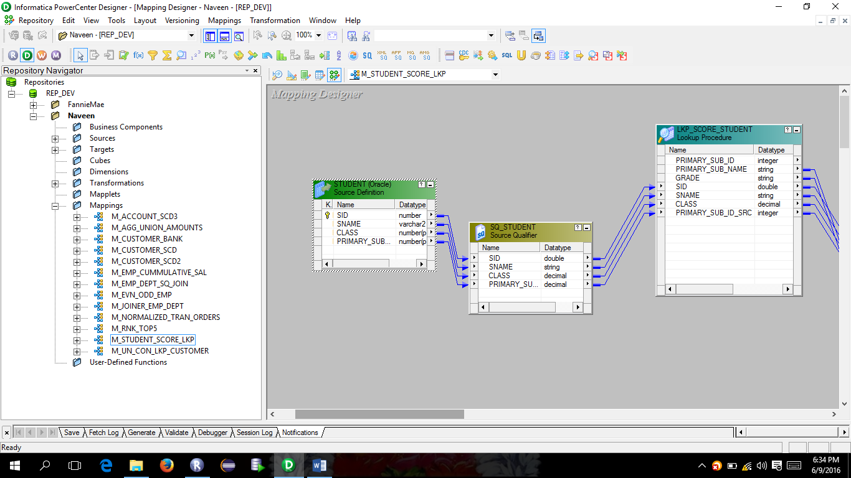

Create a lookup transformation , when you create select scores table, and drag and drop student(sq) on the lookup, now give the condition as shown below

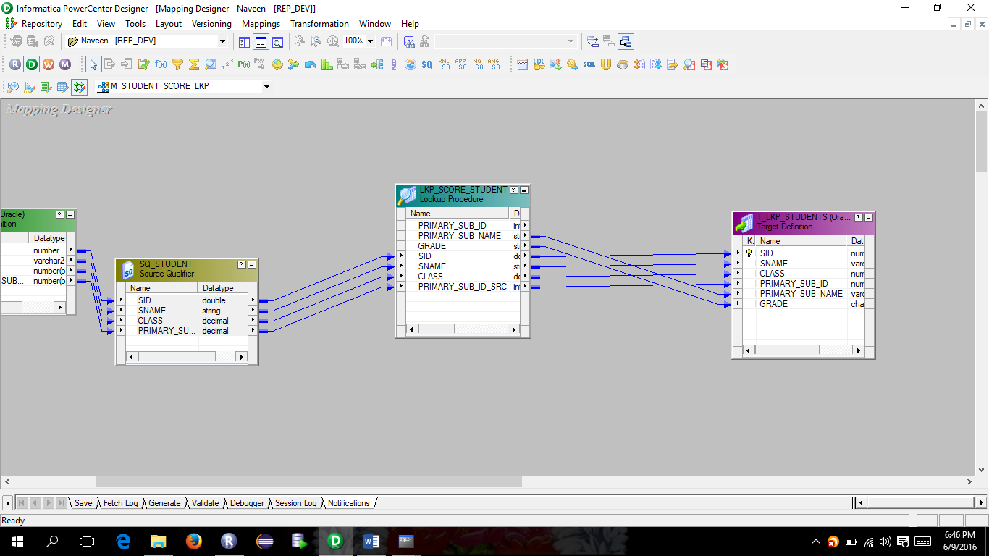

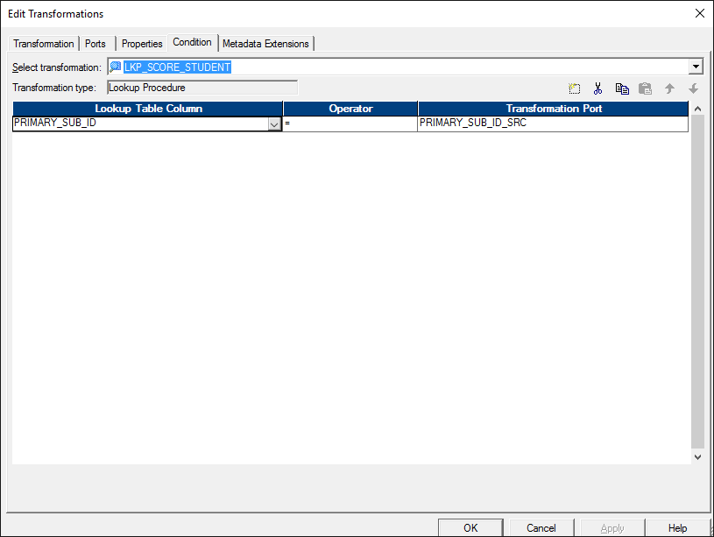

The above screen will give the lookup value either null or return the value if exists it will give the record if not null.

Below are the port information

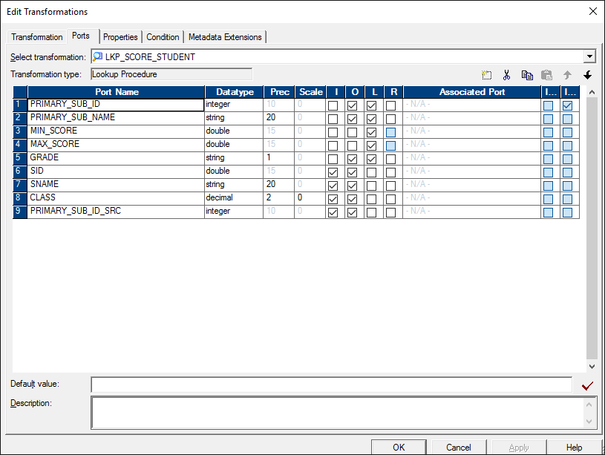

And the target will get the data from the lookup.